8051 Displaying Custom Characters On LCD (C Code) + Proteus Simulation
This post explains the idea of creating custom characters on any LCD ( e-g on 16x2 LCD ) which has HD44780U controller in it. Almost all 16x2 or 20x2 LCDs have HD44780U controller in them^{[1]}. This controller provides the functionality of CGRAM ( Character Generator RAM ). We can write character patterns on this RAM and then they can be easily displayed on the LCD. The code for custom character generation using 8051 micro-controller and Proteus simulation can be downloaded from the 'Downloads' section at the bottom of this page.
If you don't know how to interface LCD with 8051 ( e-g AT89C51 or AT89C52 ) in 8bit mode, then you should read this post first. The required circuit for displaying custom characters on LCD in 8bit mode is shown below.
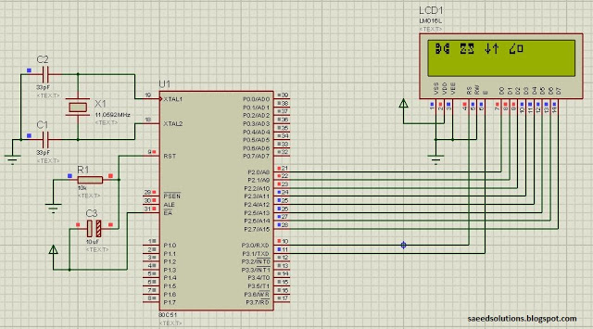
Figure 1. 8051 LCD Interfacing in 8bit mode
Port 2 is being used to write data on the LCD. Also, P3.0 pin is used as RS (Register Select for LCD) and P3.1 pin is used as E (Enable pin for LCD).
A crystal of 11.0592 MHz is used here. You can use any crystal value from 3 to 24MHz with 8051. As we know that 8051 micro controller has an architecture which executes an instruction in 12 CPU cycles ^{[2]}, hence this 11.0592Mhz crystal makes this 8051 run at 0.92 MIPS (Million of instructions per second).
Close-up picture of the LCD is shown below.
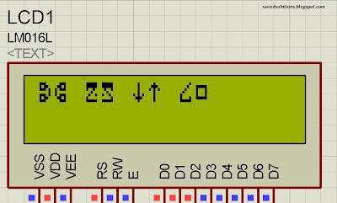
Figure 2. Custom characters displayed on LCD
Figure 2 shows the custom characters displayed on the LCD by running the code^{[3]}.

How to generate custom character ?
I am going to explain custom character generation using an example. In the figure 2, the seventh character displayed on the LCD is named 'Curvy Object' in the code. To generate this character, First make a box of 8 by 5 dots. Then fill the dots required to make the custom character you want to display. Following figure explains this concept.
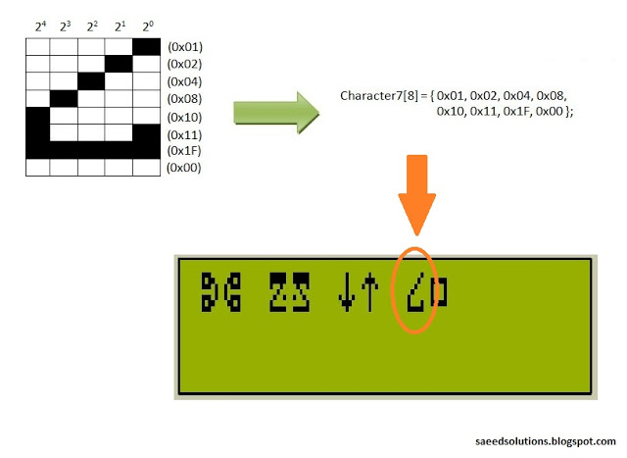
Figure 3. Custom character code array generation
After filling the dots, find out the value of each line. For example, ( in the figure 3 for 'Curvy Object' creation ) first line has a value of 0x01, because only first dot ( at 2⁰ position ) needs to be displayed. Then second line has a value of 0x02, because only one dot at 2¹ position needs to be displayed. Similarly, third line has a value of 0x04, fourth line has a value of 0x08 and fifth line has a value of 0x10. Sixth line has the two dots to be displayed, hence 0x10 + 0x01 = 0x11 is it's value. Seventh line has all the dots to be displayed, which corresponds to a value of 0x10 + 0x08 + 0x04 + 0x02 + 0x01 = 0x1F. Eight line has no dots to be displayed, so it has a value of zero. After finding out these values make an array of these values as shown in the figure 3. This array named 'Character7', which has 8 bytes of data will be transmitted to the CGRAM of LCD.
We can program 8 custom characters when we are using 5x8 font in the LCD settings. And we can program 4 custom characters when we are using 5x10 font in the LCD settings. I have used 5x8 font in the code, hence 8 custom characters can be programmed. Using similar approach to make the custom character, 8 custom characters were defined in the code. These custom character arrays are shown below^{[4]}.
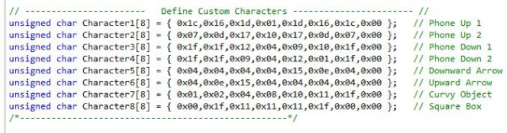
Figure 4. Custom character arrays used in the code

Code
The code for the lcdinit() function is shown below^{[5]}. This function is used to initialize the LCD properly with the custom characters.
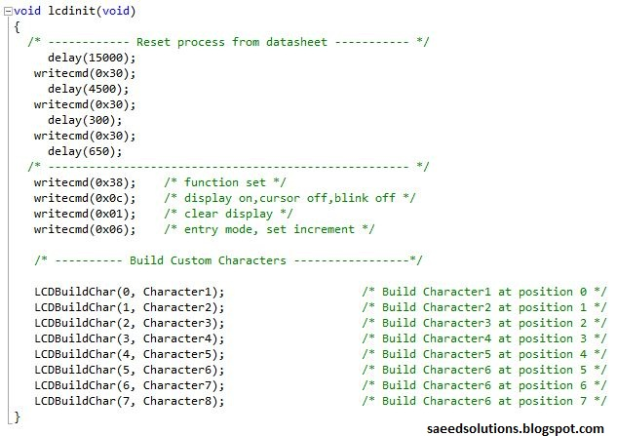
Figure 5. LCD Initialization code
'LCDBuildChar()' function is used to transfer the custom character array to the CGRAM of the LCD. This function is programming all the 8 custom characters in the CGRAM of the LCD. This function is shown below.
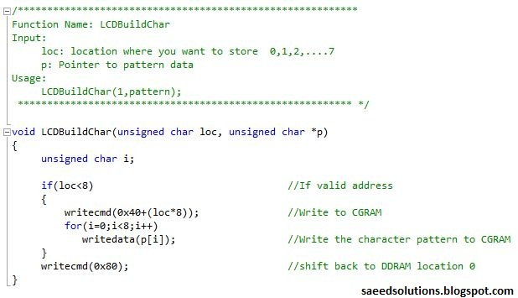
Figure 6. Custom Character Build Function
For the details of this function, please refer to the "CGRAM Programming Section" of HD44780U datasheet.
After the programming of these custom characters, we can display them on the LCD using the writedata() function. For example, to display custom character 1 on the LCD just write writedata(0x00);. Similarly, to display custom character 7 ( Curvy Object ) on the LCD, just write writedata(0x06); in the main function. The code for the main function is displayed below.
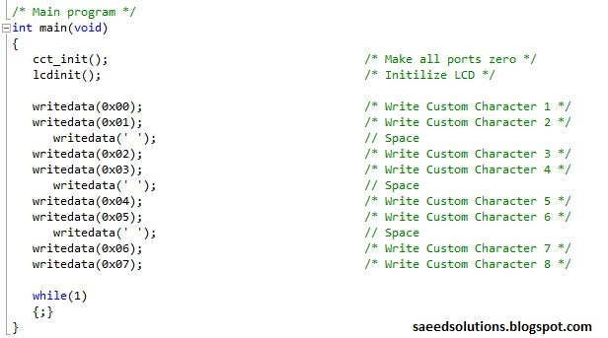
Figure 7. Main function code for calling custom characters
In the main function, after initializing the LCD, all the custom characters are being displayed. You can change the custom character array to change it's shape. And then writedata() function can be used to display that new custom character on the LCD. It is that easy.
You can leave your comments in the comment section below.

Notes and References
^{[1]} Most 16x2 LCDs have HD44780U controller inside them. So, the datasheet for HD44780U controller explains all the commands you can give to the LCD. You can get HD44780U controller datasheet from Google.
^{[2]} From http://en.wikipedia.org/wiki/Intel_MCS-51
^{[3]} This code was compiled using Keil uvision4 software. It is provided in the 'Downloads' section at the bottom of this page.
^{[4]} You can match these custom character array definitions with the characters displayed on the LCD in Figure 2.
^{[5]} LCD initialization procedure is also given in the HD44780U controller datasheet.

